Ideation Phase

Define the Problem Statements

|  |  |
| --- | --- |
| Assignment Date | 19 October 2022 |
| Student Name | Ms. SRIMATHI V |
| Student Roll Number | 732919ITR106 |
| Maximum Marks | 2 Marks |

Mr.Veerapandiya Kattabomman is a 65 years old man. He had a own farming land and do Agriculture for past 30 Years , In this 30 Years he Faced a problem in Choosing Fertilizers and Controlling of Plant Disease.

* Veerapandiya Kattabomman wants to know the better recommendation for
* fertilizers for plants with the disease. He has faced huge losses for a long time.
* This problem is usually faced by most farmers
* Mr. Veerapandiya Kattabomman needs to know the result immediately.

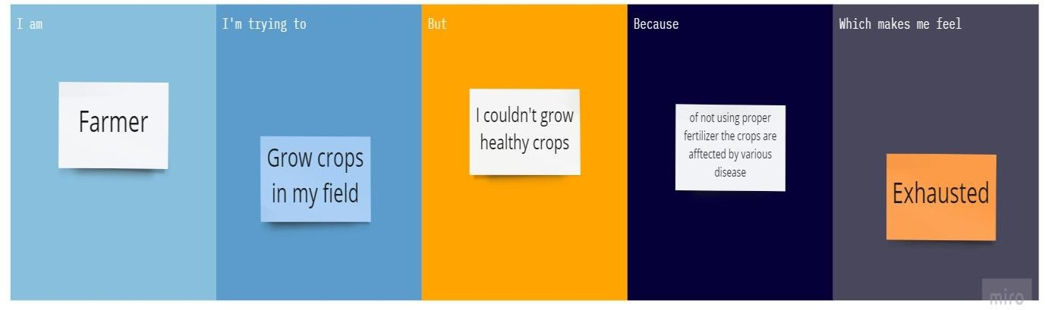

|  |  |
| --- | --- |
| **Problem Statement** | |
| I am(Customer) | A farmer |
| I’m trying to | Grow healthy crops |
| But | The crops are affected by diseases |
| Because of | Problem in Choosing Fertilizers and Controlling of Plant Disease. |
| Which makes me feel | Exhausted because of facing huge losses for a long time |